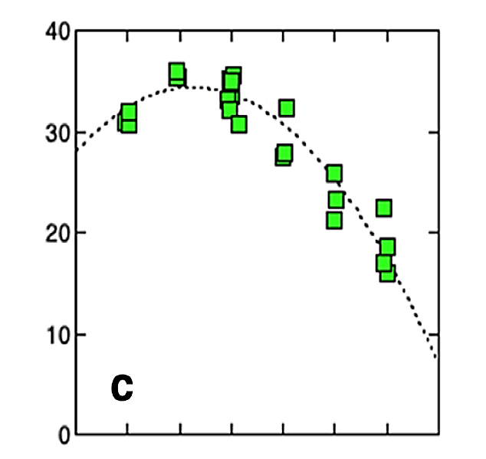
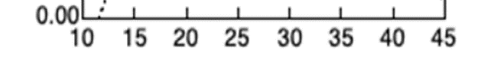
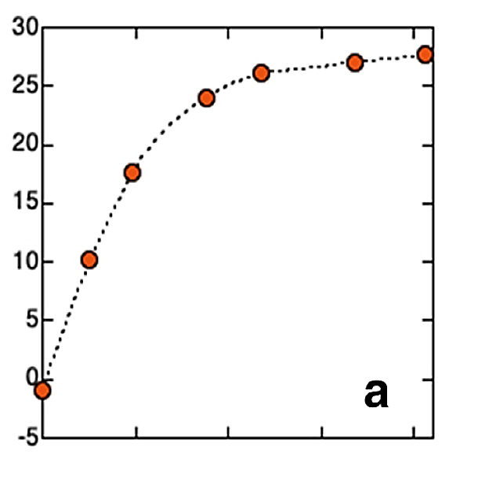
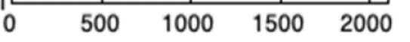
Leaf temperature (ºC)
Light intensity (µmol/m²/s)
Photosynthesis rate
(CO₂ absorption in µmol/m²/s)
Photosynthesis rate
(CO₂ absorption in µmol/m²/s)
Leaf temperature (ºC)
Light intensity (µmol/m²/s)
Photosynthesis rate
(CO₂ absorption in µmol/m²/s)
Photosynthesis rate
(CO₂ absorption in µmol/m²/s)
The data above is from a larger study into the measurable factors which can influence photosynthesis as measured by CO₂ absorption by a leaf. The paper “Linking remote sensing parameters to CO2 assimilation rates at a leaf scale” was authored by Kouki Hikosaka and Katsuto Tsujimoto, and published in March 2021 in the Journal of Plant Research (a peer reviewed journal)
The graph on the left investigated the effect of leaf temperature on the rate of photosynthesis, while the graph on the right investigated the effect of light intensity hitting the leaf on the rate of photosynthesis.
The data above is from a larger study into the measurable factors which can influence photosynthesis as measured by CO₂ absorption by a leaf. The paper “Linking remote sensing parameters to CO2 assimilation rates at a leaf scale” was authored by Kouki Hikosaka and Katsuto Tsujimoto, and published in March 2021 in the Journal of Plant Research (a peer reviewed journal)
The graph on the left investigated the effect of leaf temperature on the rate of photosynthesis, while the graph on the right investigated the effect of light intensity hitting the leaf on the rate of photosynthesis.

Identification of trends and relationships
As the temperature of a leaf increases, the rate of photosynthesis (as measured by CO₂ absorption) initially increases and then decreases. The rate increases from 32.5 µmol/m²/s at a temperature of 15ºC to a maximum of 35 µmol/m²/s at approximately 22 ºC. The rate then consistently decreased to a minimum of 15 µmol/m²/s at 40 ºC. The trend appears to be a second order polynomial with the relationship best described by:
Rate = -0.06 x T² + 2.4 x T + 9.0
The data shows that photosynthesis has an optimal temperature range and that outside this range the rate of photosynthesis reduces significantly.
As the light intensity increases, the rate of photosynthesis initially increases but then approaches a maximum value. The trend looks like a logarithmic curve; however, the data is not well predicted by a logarithmic relationship (R² = 0.88). As light intensity increases from 0 to 500 µmol/m²/s, the rate of photosynthesis increased from -1 to 10 µmol/m²/s. Yet as light intensity increases from 1200 to 1700 µmol/m²/s (also an increase of 500 µmol/m²/s), the rate of photosynthesis only increased from 26 to 27 µmol/m²/s. The data would suggest that very small increases of light as the day begins would lead to rapid and significant increases in photosynthesis by plants; however, further increases in light intensity in the middle of the day do not significantly increase the rate of photosynthesis.

Identification of Uncertainty and Limitations
There is a significant degree of uncertainty in the data relating leaf temperature to photosynthesis. The greatest uncertainty, as indicated by the error bars, occurs at 40 ºC. At this temperature the rate of photosynthesis was 23 ± 3.5 µmol/m²/s, a range of 19.5 to 26.5. This is approximately a 30% range, and are reflects a significant degree of uncertainty in the values. The uncertainty in other rates was slightly lower than this in general. However, the trend line does go through all the ranges of uncertainty, and appears to very closely describe the trend(R² = 0.99). This implies that although there is uncertainty in the data, the trend and mathematical relationship may have relatively low uncertainty.
There appears to be very little uncertainty in the data relating light intensity to photosynthesis rate. There is no uncertainty shown in the data points and the trend line shown matches the data almost exactly. However, the trend shown is difficult to describe with standard mathematical algorithms. This suggests the pattern in the data is reasonably unique. It may therefore be difficult to use this trend to make predictions beyond the data collected.
Both sets of data are limited in the amount of data collected. In the first data set the range of temperatures investigated is too narrow. It is relatively common for temperatures of leaves to be below 15ºC and above 40ºC, yet temperatures beyond these were not investigated. It is difficult to be certain that the trend shown in the data between 15ºC and 40ºC will be maintained beyond this range. The second data set appears to have few limitations. However, given the unique trend line it would be appropriate to have more data points to confirm the trend.
Conclusions
Photosynthesis occurs at an optimal leaf temperature of 22ºC. The rate of photosynthesis decreases significantly either side of this optimal temperature. The relationship between leaf temperature and rate of photosynthesis is best described:
Rate of Photosynthesis = -0.06 x Temp² + 2.4 x Temp + 9.0
This has significant implications for plant growth. In Australia, daily temperature can exceed this optimal temperature for most of the day. Additionally, leaves exposed to sunlight would become hot very quickly, and for most of the day may have a temperature in the range where photosynthesis is occurring very slowly. These findings suggest that plant growth would be far greater in climate-controlled conditions where exposure to direct summer sun is limited.
Photosynthesis appears to need only a moderate amount of sunlight to occur at an optimal rate. Light intensities of 1000 µmol/m²/s or above all appear to cause a similar and maximum rate of photosynthesis. Light intensity in many regions of the world exceed 1500 µmol/m²/s, however this elevated amount of light does not increase photosynthesis very much.
Both results suggest that plant growth is best (optimal) at relatively low daily temperatures with moderate amount of light intensity. Plant growth would therefore be optimal in relatively shaded conditions, where a temperature of approximately 22 ºC can be maintained. These conditions describe an enclosed growing area where temperature can be maintained, but with shading incorporated into the walls and ceiling to allow only a moderate amount of light (and thus avoiding excess cooling costs). Alternatively, an ideal growth area would be a climate-controlled facility with artificial lighting at an intensity of approximately 1200 µmol/m²/s.

Identification of Reliability and Validity
The data appears reliable. The article it is drawn from is a peer reviewed journal and thus the method has been reviewed and considered reliable. There is some uncertainty in the data for leaf temperature, however the mathematical relationship identified does describe the trend in the data very well. There appears very little uncertainty in the data relating to light intensity, suggesting that this data is highly reliable.
The conclusions drawn form this data appear valid, but only within a limited range of applications. In the leaf temperature data, the range of the temperatures investigated was too narrow, and it is possible that the mathematical relationship identified would not be the same outside this range. In addition, the conclusions are not likely to be valid for other plant species. Leaf structure varies significantly between plant species, and it is therefore unlikely that the findings of this investigation are applicable to all plant species. This latter point significantly reduces the validity of any broad conclusions drawn from the data.

